IOT CA1
Adas

Hardware
List of hardware and fritzing diagram
- Raspberry pi – 4
- LED Lights
- Transparent Display
- GPS Module- Adafruit Ultimate GPS Breakout
- Camera Module – piCcamera v2
- PowerBank

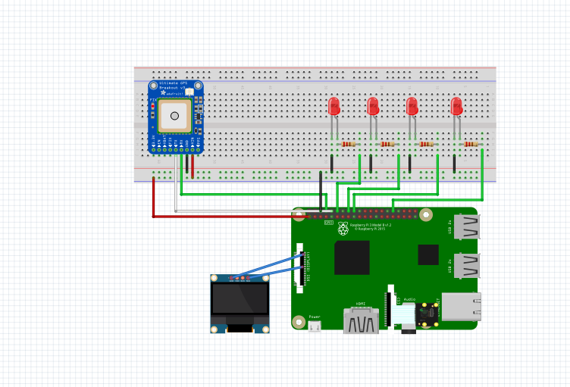
Data, Data Storage and Data Processing
Details of senor data , frequency of data
Security and Privacy
Network Diagram
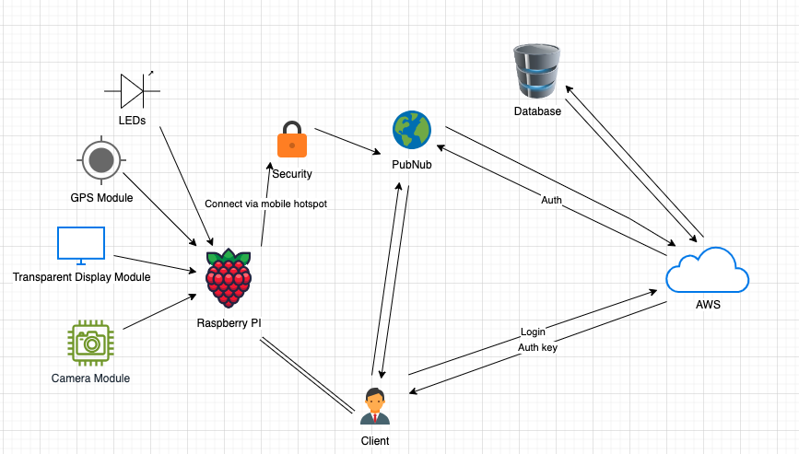
Security precautions
- Use robust monitoring and logging to keep track of system activity and identify security incidents. Configure alerts to be notified of unusual or suspicious activity.
- Use effective encryption techniques to encrypt user credentials. This makes sure that the data is impossible to read even in the event that an attacker manages to access it.
- Implement strong methods of authentication for the API endpoints. To guarantee that only authorized users can access our app, we can use OAuth tokens or API keys.
- Advise users on suggested security steps. Tell them to report any odd behavior, update the firmware on their devices, and create secure passwords.

The UI, User and testing
How will the user connect:
- The user will first sign up and log in to their account

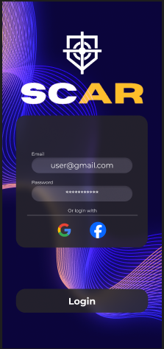

- If they are going to play a game and want their scope to track their statistics, they will first need to click on the start game button, once clicked the user will be greeted with an option to link their stats to a weapon and finally a configuration screen where the user can do a last second adjustment
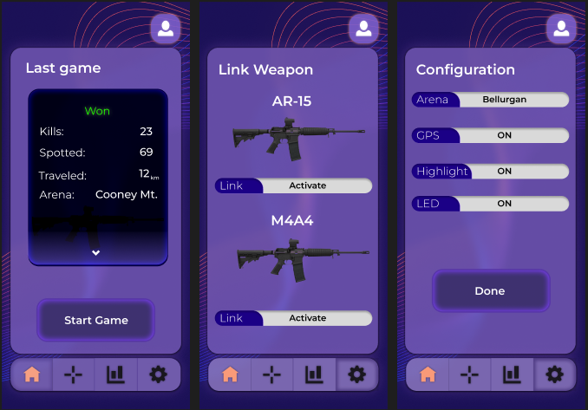
Available Data:
- The user will be able to see statistics such as the kills they did and distance travelled during a match, to view their statistics they will have to interact with the statistics functionality, triggered by a button located at the bottom of the screen
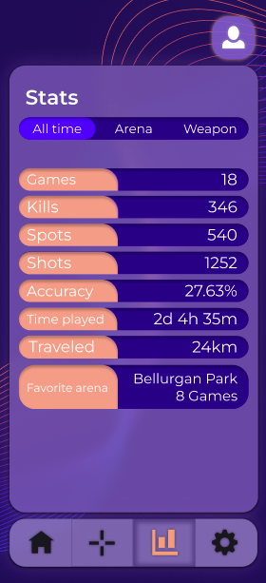
- The user’s statistics will be converted into points where other users will be able to see them by accessing the leaderboard
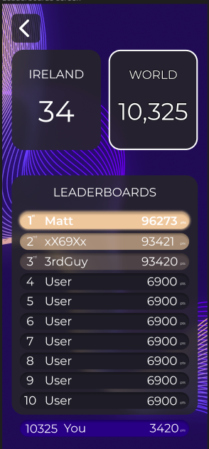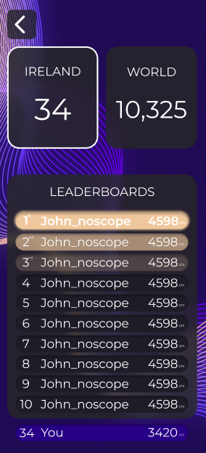

- The data showed will be different according to the user choice, so if the user only choose the regional ranking only the users in the same regions will be shown, and if they choose the world rankings every user point will be show on the leaderboard
- The application will keep track of the crosshair specification that the user made, user will be able to access this data and modify it by using the crosshair editor
